1. Take a screenshot of the HAPI-FHIR server’s default web UI and submit it with your other lab materials.

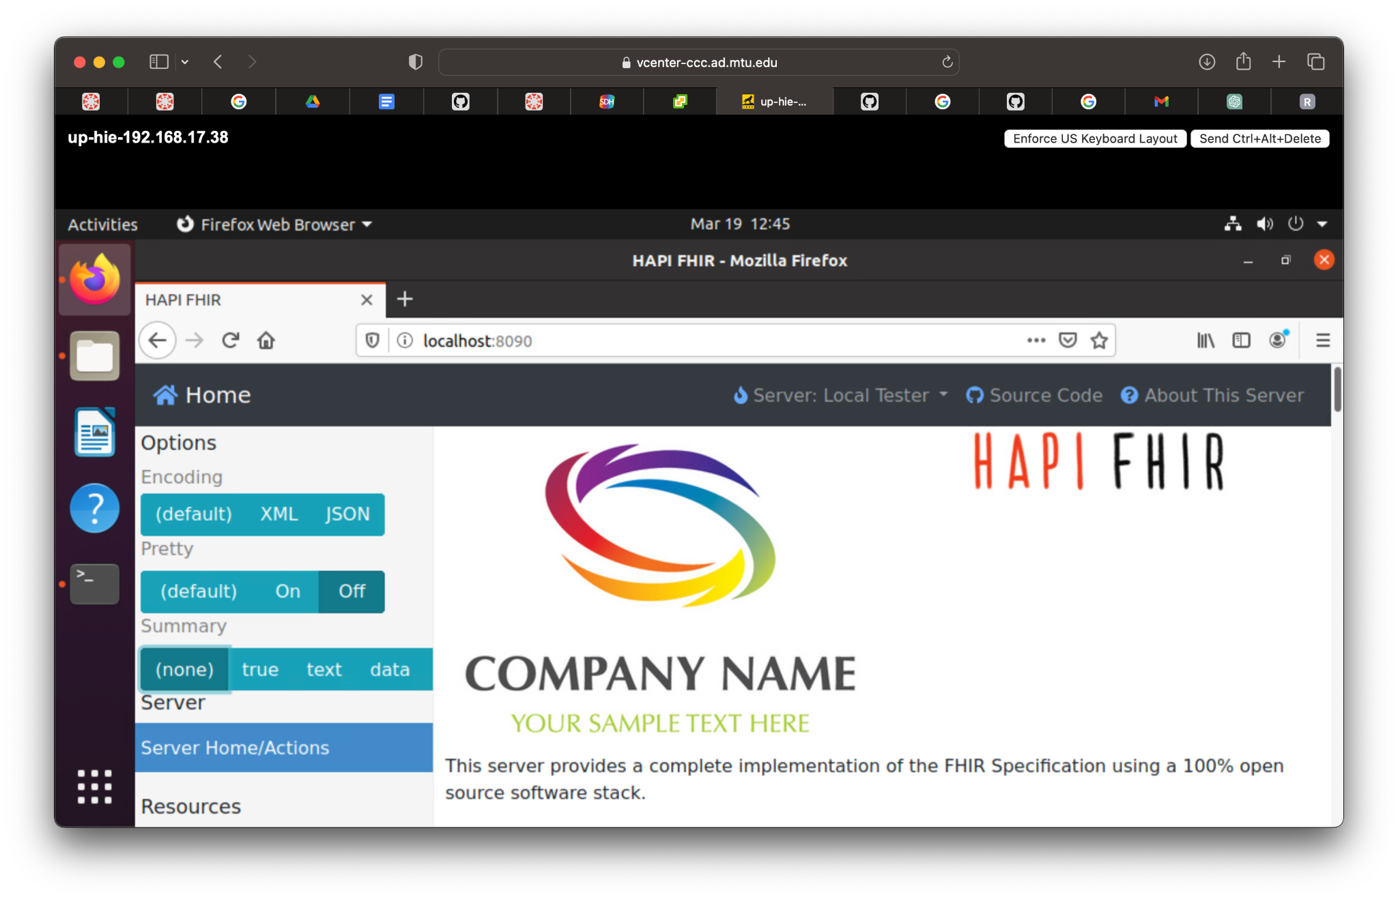

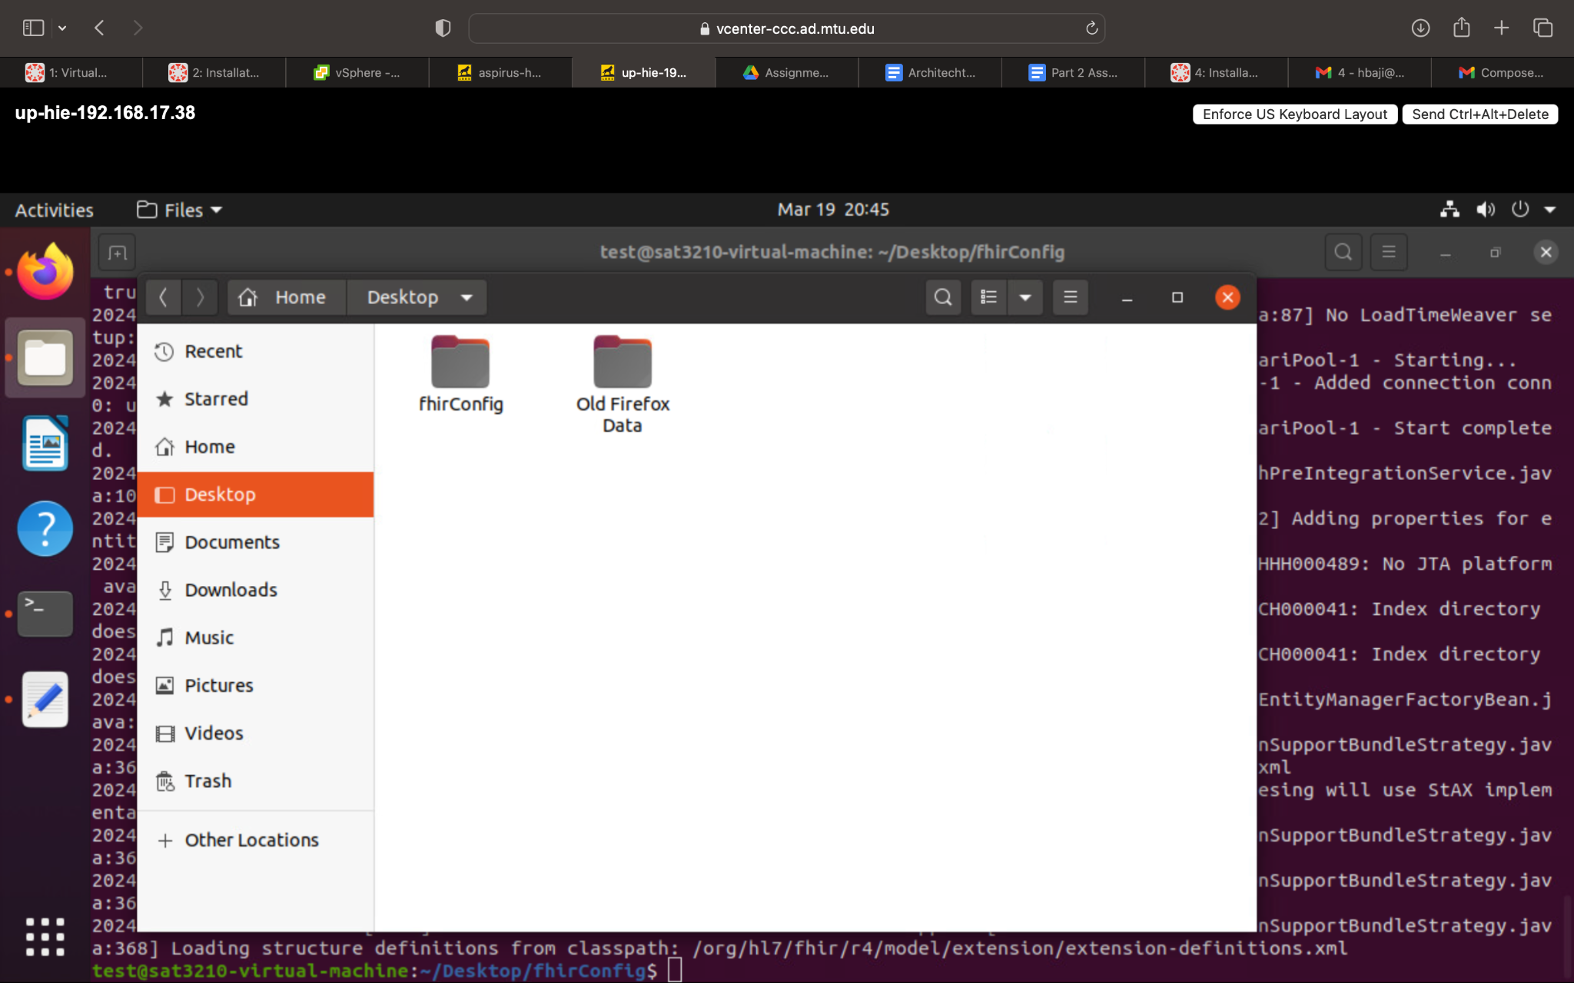

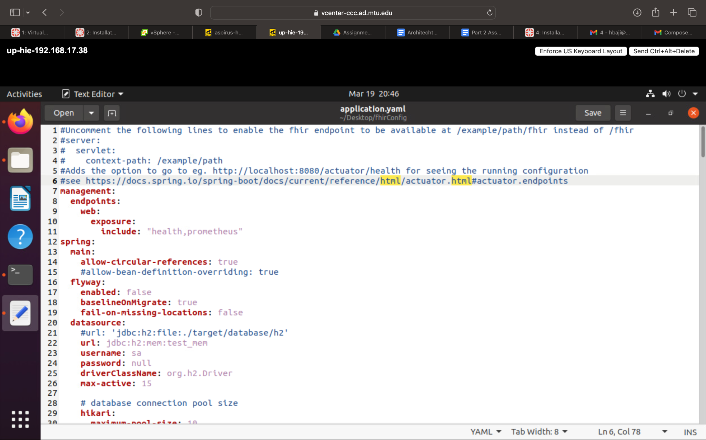

1. What command would you use to check the total, used, and free memory in system if you thought the HAPI-FHIR server was not running properly due to lack of memory?

**sudo netstat -tuln | grep 8080**  is used to check and free memory in the system if the HAPI-FHIR server was not running properly due to lack of memory.

1. You've updated the firewall rules on your Ubuntu server and want to check if the port (say 8080) used by the HAPI-FHIR server is open. What command would you use?

**sudo netstat -tuln |** Is the command used for checking the port used by the HAPI-FHIR.

1. If the HAPI-FHIR server fails to start, you want to ensure that there are no other processes occupying the default port (8080). What command should you use to check if the port 8080 is currently in use?

If the HAPI-FHIR server fails to start, we have to ensure that there are no other processes occupying the default port (8080).

Command use to check if the port 8080 is currently in use : sudo lsof -i :8080

1. Replace the existing hospital images with (OpenEMR 7.0.1) with OpenEMR 6.0.1 already installed using a template. You will have to convert the template into a new vm for each of the 4 hospitals. Take a screenshot of one of the hospitals to verify the OpenEMR template has been installed and configured correctly.

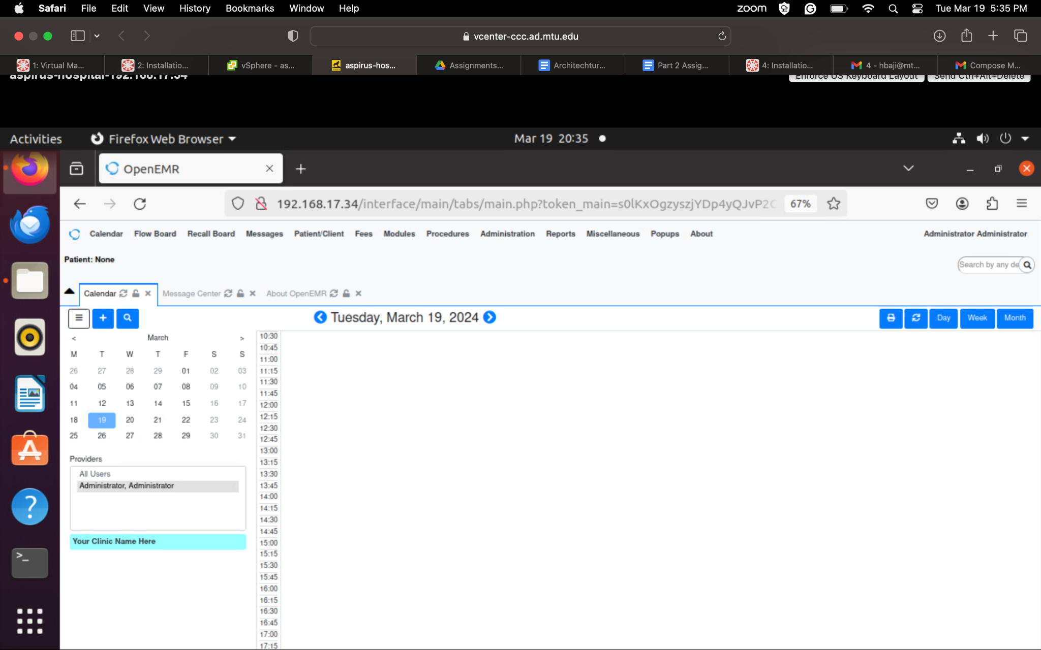

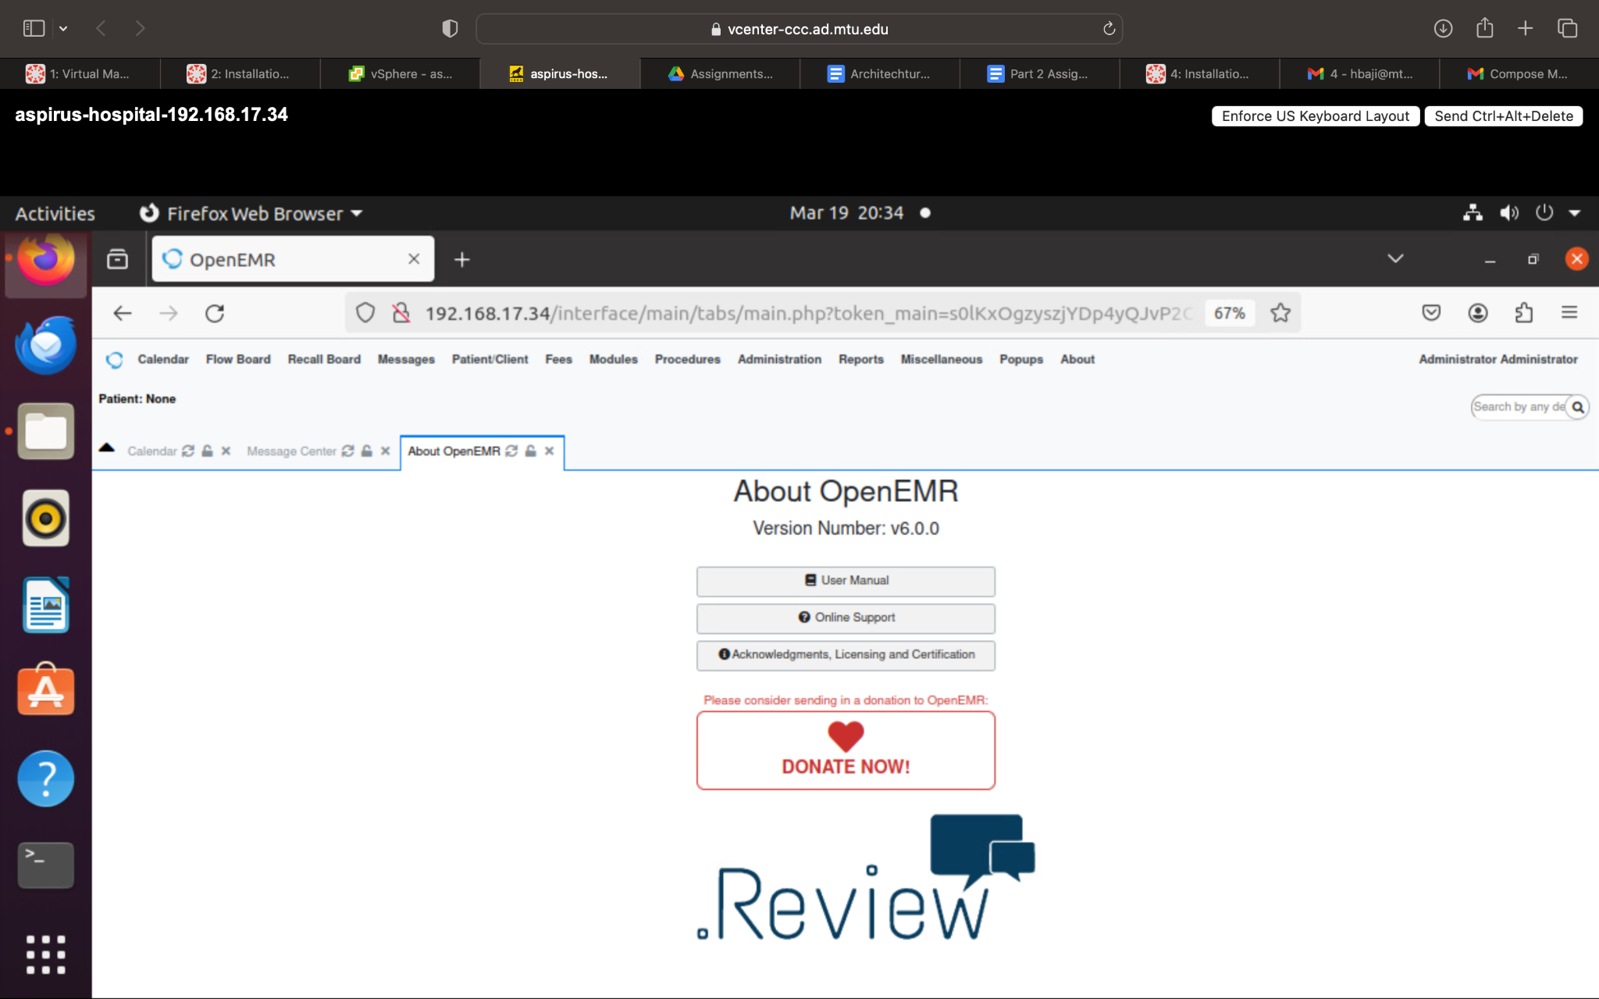

Bonus

6.Customize the default HAPI-FHIR UI (web page) so that it says, “Upper Peninsula Health Care Network” instead of “Company Name” and “The Health Information Exchange for the Upper Peninsula“ instead of “Your Sample Text Here”. Submit a screenshot to verify your work.